Lab 1

Todd Goldfinger
12/25/02

Web-Safe Colors

Goal: To implement an algorithm that converts any RGB image into Web-Safe colors.

I implemented the algorithm in matlab. It simply maps the color of each pixel of the image to that color's corresponding Web-Safe color. Following are the mapping values from the gray-scale to the web-safe colors.
Gray-Scale Range | 0-41 | 42-84 | 85-127 | 128-171 | 172-212 | 213-255
Web-Safe Color | 0 | 51 | 102 | 153 | 204 | 255
To test the code, I ran the algorithm on Fig. 1a below to produce Fig. 1b. You should be able to see how mapping RGB space to Web-Safe color space looses most of the color information. In fact, the color cube has (2^8)^3 = 16777216 colors, while the web-safe color cube has only 6^3 = 216 colors.

Fig. 1a below and 1b below that. Note how few colors 1b has.
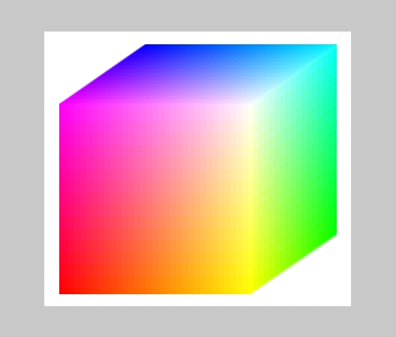
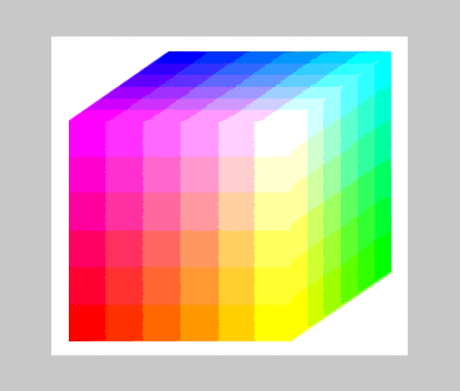

Get the matlab code here.

next (Pseudo Color)

